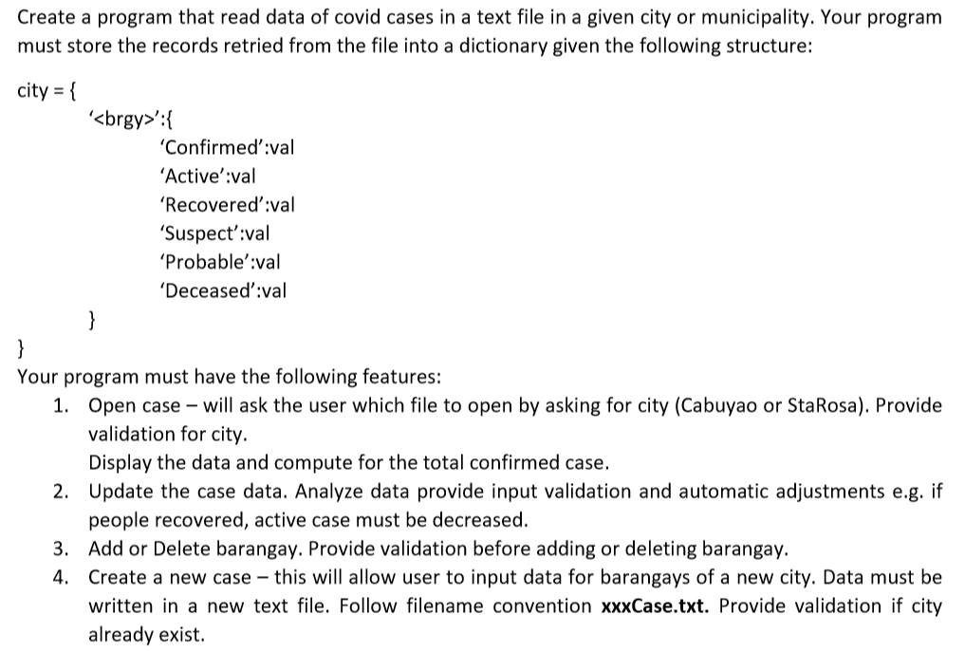

|  |  |  |  |  |  |  |
| --- | --- | --- | --- | --- | --- | --- |
| Code | Test Name | Input | Expected | Output | Passed? | Remarks |
| 1 | Open Case | A  Cabuyao  a | <show all compare with text file> |  | Yes |  |
| 1V1 | Open Case for non existing city | A  Carmona | Try again |  | Yes |  |
| 1V2 | Open Case for city without data | A  Calamba  a | No tracked barangay |  | Yes |  |
| 2A | Update Case Data Active | A  Sta Rosa  B  Ibaba  A  10 | Ibaba – 10 active cases |  | Yes |  |
| 2AV1 | Update Case Data Active invalid | A  Sta Rosa  B  Ibaba  A  -1 | Try again |  | Yes |  |
| 2B | Update Case Data Recovered Adjust active | A  Sta Rosa  B  Dila  B  5  Y | Dila – 0 active 5 recovered |  | Yes |  |
| 2BV1 | Update Case Data Recovered Invalid | A  Sta Rosa  B  Dila  B  -1 | Try again |  | Yes |  |
| 2C | Update Case Data Suspect | A  Sta Rosa  B  Labas  C  100 | Labas - suspect 100 |  | Yes |  |
| 2CV | Update Case Data Suspect Invalid | A  Sta Rosa  B  Labas  C  -10000 | Try again |  | Yes |  |
| 2D | Update Case Data probable | A  Sta rosa  B  Aplaya  D  100 | Aplaya – probable 100 |  | Yes |  |
| 2DV | Update Case Data Probable Invalid | A  Sta Rosa  B  Aplaya  D  -10 | Try again |  | Yes |  |
| 2E | Update Case Data Deceased Adjust Active | A  Cabuyao  B  MARINIG  E  2  Y | Margining – 2 deceased and 0 active |  | Yes |  |
| 2E | Update Case Data Deceased No Adjust | A  Cabuyao  B  Butong  E  2  N | Butong – 2 deceased, 4 confirmed, 2 active |  | Yes |  |
| 2EV | Update Case Data Deceased Invalid | A  Cabuyao  b  Marinig  E  -1 | Try again |  | Yes |  |
| 3A | Add barangay | A  Cabuyao  C  Barangay 1 | Barangay 1 0 0 0 0 0 0 |  | Yes |  |
| 3AV1 | Add barangay Existing barangay | A  Cabuyao  C  Pulo | Try again |  | Yes |  |
| 3AV2 | Add barangay empty name | A  Cabuyao  C | Try again |  | Yes |  |
| 3B | Delete barangay | A  Cabuyao  D  Pulo | Successfully deleted barangay |  | Yes |  |
| 3BV | Delete non existing barangay | A  Cabuyao  D  Don jose | Try again |  | Yes |  |
| 4 | Create Case | B  Calamba | City Created  New text file in data folder |  | Yes |  |
| 4V1 | Create Case for Existing City | B  Calamba | Try Again |  | Yes |  |
| 4V2 | Create Empty City | B | Try Again |  | Yes |  |
|  |  |  |  |  |  |  |
|  |  |  |  |  |  |  |
|  |  |  |  |  |  |  |
|  |  |  |  |  |  |  |
|  |  |  |  |  |  |  |
|  |  |  |  |  |  |  |
|  |  |  |  |  |  |  |
|  |  |  |  |  |  |  |
|  |  |  |  |  |  |  |
|  |  |  |  |  |  |  |
|  |  |  |  |  |  |  |
|  |  |  |  |  |  |  |
|  |  |  |  |  |  |  |
|  |  |  |  |  |  |  |
|  |  |  |  |  |  |  |
|  |  |  |  |  |  |  |
|  |  |  |  |  |  |  |
|  |  |  |  |  |  |  |
|  |  |  |  |  |  |  |
|  |  |  |  |  |  |  |
|  |  |  |  |  |  |  |
|  |  |  |  |  |  |  |
|  |  |  |  |  |  |  |
|  |  |  |  |  |  |  |
|  |  |  |  |  |  |  |
|  |  |  |  |  |  |  |
|  |  |  |  |  |  |  |
|  |  |  |  |  |  |  |
|  |  |  |  |  |  |  |
|  |  |  |  |  |  |  |
|  |  |  |  |  |  |  |
|  |  |  |  |  |  |  |
|  |  |  |  |  |  |  |
|  |  |  |  |  |  |  |
|  |  |  |  |  |  |  |
|  |  |  |  |  |  |  |
|  |  |  |  |  |  |  |
|  |  |  |  |  |  |  |
|  |  |  |  |  |  |  |
|  |  |  |  |  |  |  |
|  |  |  |  |  |  |  |
|  |  |  |  |  |  |  |
|  |  |  |  |  |  |  |
|  |  |  |  |  |  |  |
|  |  |  |  |  |  |  |
|  |  |  |  |  |  |  |
|  |  |  |  |  |  |  |
|  |  |  |  |  |  |  |
|  |  |  |  |  |  |  |
|  |  |  |  |  |  |  |
|  |  |  |  |  |  |  |
|  |  |  |  |  |  |  |
|  |  |  |  |  |  |  |
|  |  |  |  |  |  |  |
|  |  |  |  |  |  |  |
|  |  |  |  |  |  |  |
|  |  |  |  |  |  |  |
|  |  |  |  |  |  |  |
|  |  |  |  |  |  |  |
|  |  |  |  |  |  |  |
|  |  |  |  |  |  |  |
|  |  |  |  |  |  |  |
|  |  |  |  |  |  |  |
|  |  |  |  |  |  |  |
|  |  |  |  |  |  |  |
|  |  |  |  |  |  |  |
|  |  |  |  |  |  |  |
|  |  |  |  |  |  |  |
|  |  |  |  |  |  |  |
|  |  |  |  |  |  |  |
|  |  |  |  |  |  |  |
|  |  |  |  |  |  |  |
|  |  |  |  |  |  |  |
|  |  |  |  |  |  |  |
|  |  |  |  |  |  |  |
|  |  |  |  |  |  |  |
|  |  |  |  |  |  |  |
|  |  |  |  |  |  |  |
|  |  |  |  |  |  |  |
|  |  |  |  |  |  |  |
|  |  |  |  |  |  |  |
|  |  |  |  |  |  |  |
|  |  |  |  |  |  |  |
|  |  |  |  |  |  |  |
|  |  |  |  |  |  |  |
|  |  |  |  |  |  |  |
|  |  |  |  |  |  |  |
|  |  |  |  |  |  |  |
|  |  |  |  |  |  |  |
|  |  |  |  |  |  |  |
|  |  |  |  |  |  |  |
|  |  |  |  |  |  |  |
|  |  |  |  |  |  |  |
|  |  |  |  |  |  |  |
|  |  |  |  |  |  |  |
|  |  |  |  |  |  |  |
|  |  |  |  |  |  |  |
|  |  |  |  |  |  |  |
|  |  |  |  |  |  |  |
|  |  |  |  |  |  |  |
|  |  |  |  |  |  |  |
|  |  |  |  |  |  |  |
|  |  |  |  |  |  |  |
|  |  |  |  |  |  |  |
|  |  |  |  |  |  |  |
|  |  |  |  |  |  |  |
|  |  |  |  |  |  |  |
|  |  |  |  |  |  |  |
|  |  |  |  |  |  |  |
|  |  |  |  |  |  |  |
|  |  |  |  |  |  |  |
|  |  |  |  |  |  |  |
|  |  |  |  |  |  |  |
|  |  |  |  |  |  |  |
|  |  |  |  |  |  |  |
|  |  |  |  |  |  |  |
|  |  |  |  |  |  |  |